[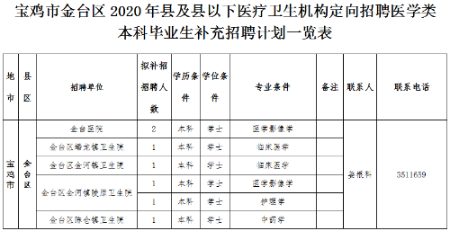](http://www.jintai.gov.cn/picture/0/703a72e2506a4739add1a2e4caeb6895.png)